* **Deploy a Static Website on AWS**
* Deploying a static website on AWS is a practical way to understand cloud services. Here's a step-by-step guide to help you create and deploy a static website using Amazon S3, with optional CloudFront for CDN and Route 53 for custom domains.

* **Step-by-Step: Deploy a Static Website on AWS**
* Prerequisites
* An AWS account
* A static website (HTML/CSS/JS files) ready to deploy

* **Step 1: Create an S3 Bucket**

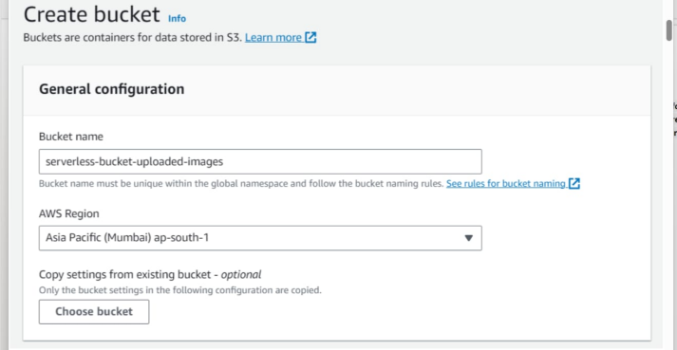

* 1. Go to the AWS Management Console
* 2. Navigate to S3
* 3. Click "Create bucket"
* 4. Set a unique bucket name (e.g., staticwebsite12)
* 5. Uncheck “Block all public access” under permissions
* 6. Acknowledge the warning and create the bucket

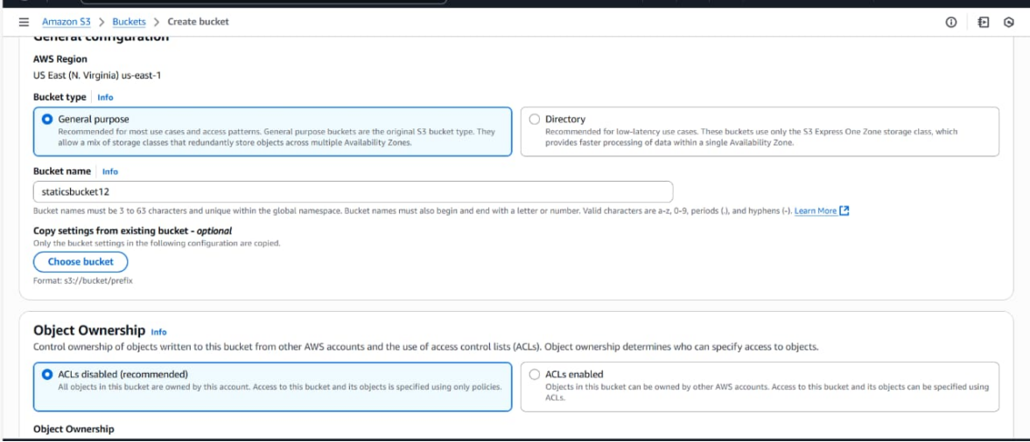

**Step 2: Upload Website Files**

* 1. Click on your bucket
* 2. Click Upload → Add files/folders
* 3. Upload your HTML, CSS, JS, and media files
* 4. Click Upload

**Step 3: Configure Bucket for Static Website Hosting**

* 1. go to Properties tab
* 2. Scroll to Static website hosting
* 3. Click Edit
* 4. Enable it and specify:
* 5. Index document: index.html
* Error document: error.html (optional)
* Save changes

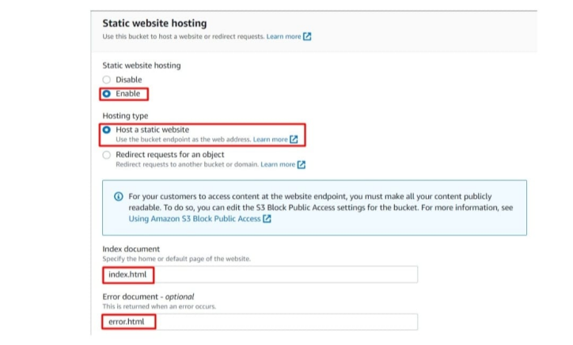

**Step 4: Make Files Public**

* 1. Select all files in the bucket
* 2. Click Actions → Make public (or set permissions manually using bucket policy)

**Example Bucket Policy**

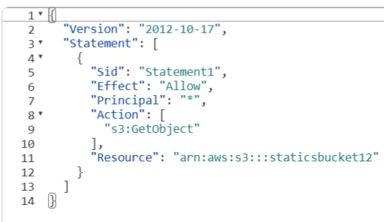

Replace my-static-site with your actual bucket name.

**Step 5:Access Your Website**

* Go to Properties → Static website hosting
* Use the Endpoint URL provided to view your live site

